Pixhawk Controlled Quadcopter: Enabling autonomous surveillance using Telemetry for effective monitoring

**Sai Rohan P.1, Dileep Kumar S.1, Khwaja Moinuddin S.1, Pavani N.1**

**Dr. K. K. Deepika2**

*1B. Tech, Dept of EEE, Vignan’s Institute of Information Technology (A), Visakhapatnam, India*.

*2Assistant Professor, Dept of EEE, Vignan’s Institute of Information Technology (A), Visakhapatnam, India*.

# Abstract

The use of self-navigating surveillance drones that have been programmed to follow different routes has shown considerable improvements in surveillance capabilities. The performance of these drones was assessed in this study, and significant results were found. With a speed of 9.82 m/s, the UAV demonstrated its ability to operate quickly and effectively. Test path analysis revealed very few differences when compared to manual operations, taking an average of two minutes to complete the path. Furthermore, in autopilot mode, the Pixhawk flight controller demonstrated better stabilization. The RTL interruption test, revealed a path spline deviation that altered the UAV's return-to-launch trajectory. These findings highlight how autonomous surveillance drones can improve operational effectiveness and surveillance coverage. Because flexibility in different paths provided, it is possible to thoroughly scan large areas in a short amount of time, optimizing the effectiveness of surveillance. Adaptive path-following and real-time data transmission improve operational dependability and situational awareness even more. As a result, autonomous surveillance drones offer a flexible and affordable option for a range of uses, such as emergency response, infrastructure monitoring, and border security. All things considered, the incorporation of autonomous surveillance drones with a variety of paths represents a major advancement in surveillance technology, providing unmatched capacity for productive and successful monitoring in a range of operational scenarios.

Keywords **-** UAV, Pixhawk, Mav-link, GPS, Telemetry, Video Transmission Receiver.

# Introduction

Unmanned Aerial Vehicles (UAVs) possess the capability to revolutionize security monitoring by offering economical, flexible, and effective means of keeping an eye on vast regions. The goal of this article is to improve security monitoring capabilities through the design and development of an autonomous surveillance drone system.

Traditional surveillance techniques frequently have coverage and scalability issues. Systems such as closed-circuit television (CCTV) are not suitable for long-term surveillance of large regions or dynamic situations. Furthermore, human mistakes can occur during manual drone operations, which might undermine the efficacy of security precautions. Autonomous surveillance drones, on the other hand, provide real-time monitoring, data collecting, and autonomous flying via sensor fusion.

This study offers a thorough analysis of the autonomous surveillance drone system's design concepts, technological elements, and operational capabilities. We go over the difficulties in creating self-governing unmanned aerial vehicles (UAVs) for security purposes and suggest creative ways to overcome them. We offer experimental findings that show the autonomous surveillance drone's functionality and efficacy in practical settings, along with some interpretations about stability, speed, altitude, payload, and GPS accuracy. In the end, this study advances autonomous surveillance systems for risk assessment and security monitoring.

# Components

To develop the surveillance drone UAV, we require the following components.

**Components Description**

|  |  |  |  |
| --- | --- | --- | --- |
| **S.no** | **Component Name** | **S.no** | **Component Name** |
| 1 | Flight Controller | 8 | Battery |
| 2 | Telemetry Module | 9 | ESC |
| 3 | Transmitter receiver | 10 | BEC Module |
| 4 | GPS Module | 11 | Landing gear |
| 5 | Frame | 12 | Camera |
| 6 | BLDC Motors | 13 | Video Transmitter |
| 07 | Propellers 1045 | 14 | Video Receiver |

Flight Controller **–** We use PIXHAWK 2.4.8 flight controller for our UAV. It acts as the central brain of a drone, responsible for processing data from various sensors and translating pilot commands into precise movements of the drone. It controls stability, navigation, and flight modes.

Telemetry Module **-** UAV is designed to be compatible with the Ardu-pilot (Mission Planner) system, which offers seamless integration with these popular flight controller platforms. It facilitates a two-way telemetry connection between the drone and the ground station, enabling real-time data exchange and control between the two. Operating at a frequency of 915MHz, the telemetry module ensures robust and reliable communication with the drone over significant distances.

Transmitter Receiver **–** To control our drone manually we are using a FLYSKY I6 receiver and transmitter. It allows for commanding essential flight maneuvers such as ascending, descending, turning, and adjusting speed. Moreover, pilots can issue flight commands such as takeoff, landing, and engaging various flight modes effortlessly through the transmitter. It has various controls and buttons for THROTTLE, PITCH, ROLL, YAW and auxiliary functions.

GPS Module **-** The GPS module M8N is a highly advanced and reliable positioning device designed to provide

accurate and precise location data for drones and other unmanned aerial vehicles (UAVs). It supports various communication interfaces, including UART, I2C, and SPI, allowing seamless integration with a wide range of flight controllers and navigation systems.

Frame **–** We used F450 UAV frame, is a versatile and reliable structure for building multirotor drones. Its sturdy construction, modular design, and compatibility with various components make it ideal for professional applications. With a distinctive X-shaped layout.

BLDC Motor **–** We used an A2212/13T 1000KV Brushless dc motor for our drone. It offers balance torque and efficiency and stability. This motor provides 800 – 900 grams of thrust with 1045 prop sizes.

Battery **–** We used 4200mah 11.1 V 3S LiPo (lithium polymer) battery. With its 3-cell configuration and generous capacity of 4200mAh, this battery offers 10Min of flight time and consistent power delivery.

## Applications

The survillance Quad-copter will have applications in the following areas: Security and Law Enforcement, Infrastructure Inspection, Agriculture and Precision Farming, Surveying and Mapping, Infrastructure Security.2

# Block Diagram and Working of UAV

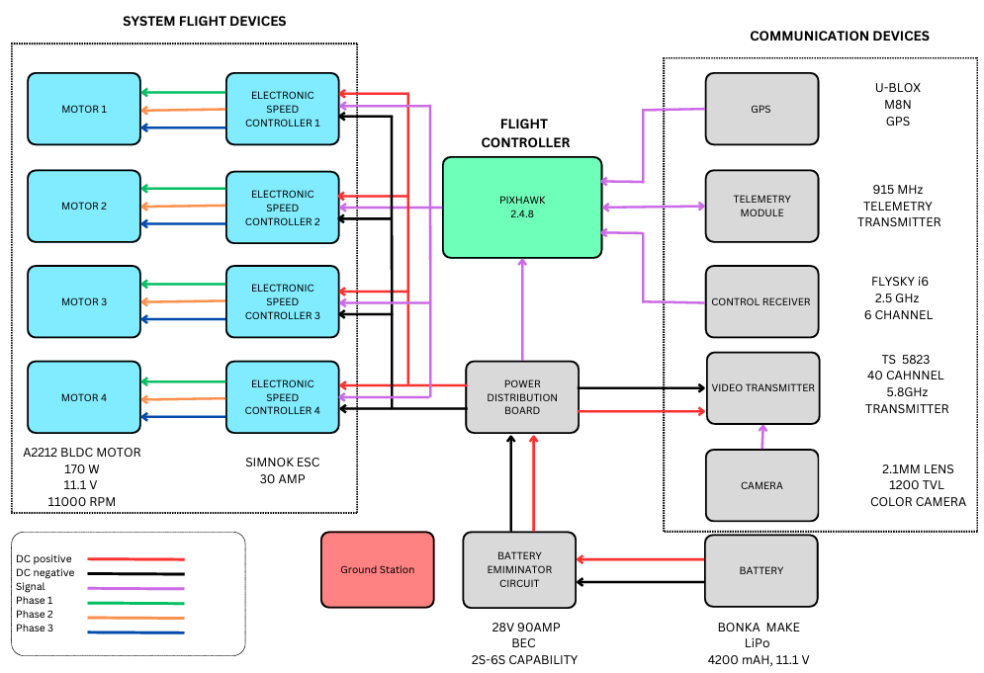

## Methodology for achieving UAV Flight

A quadcopter operates on the principle of lift generation through the rotation of four rotors. Each rotor is positioned at a corner of the quadcopter's frame, enabling it to achieve stability and control through differential thrust. When the rotors spin, they create an upward force known as lift. This lift counteracts the force of gravity, allowing the quadcopter to become airborne.

As we increase the thrust sticks upwards on the transmitter the speed of all the four motors increases then the drone tends to move upwards.

Similarly, when we move the thrust sticks downwards all four motors speed will gradually reduce and the drone moves downwards.

To control the Yaw motion when we rotate the yaw stick to the right side then the total drone rotates to right. Similarly, when we rotate yaw stick to the left the drone will rotate to left. As shown in the above figure -9.

To control the forward and backward motion of the drone when we move the Pitch stick to upwards then the drone tends to move forward in the similar way when we move the Pitch stick to downwards then the drones come backward as shown in above.

To move the right and left moments of the drone when we move the Roll stick to the right then the drone bends to the right side as the left side motor speed is increased and the drone moves to the right side. In the same way, if we move the Roll stick to the left side then the left-side motor rotates at slow speed and then bends to left as the right-side motor speed increases then the drone is moved to the left side as shown.

## UAV Flight Modes

There are a variety of flight modes in Pixhawk-based UAV’s. We mainly use 6 types of flight modes

**Stabilize Mode**: Stabilize mode is the most basic flight mode and is typically used for manual control of the quadcopter. In this mode, the pilot directly controls the throttle, pitch, roll, and yaw of the UAV using the transmitter’s joysticks.

**Altitude Hold Mode*:*** Altitude Hold mode enables the quadcopter to maintain a constant altitude without pilot input. Once activated, the flight controller adjusts the throttle to hold the UAV at the current altitude with the help of a barometer.

**Position Hold Mode:** Position Hold mode allows the quadcopter to maintain its current position in space without drifting. By integrating GPS data, the flight controller continuously calculates the UAV’s position and adjusts motor speeds to counter external forces such as wind.

**Loiter Mode:** Loiter mode is similar to Position Hold mode but incorporates additional features for improved stability and performance. In Loiter mode, the quadcopter not only maintains its position but also holds its altitude. This makes it suitable for scenarios where the UAV needs to remain stationary for extended periods.

**Return to Launch (RTL) Mode:** RTL mode is a safety feature designed to bring the quadcopter back to its

takeoff point in case of signal loss or emergency situations(fail-safe). When activated, the UAV automatically initiates a return-to-home sequence, ascending to a predefined altitude, navigating back to the launch point using GPS, and landing safely.

**Land Mode:** Land mode instructs the quadcopter to descend and land at its current location. Land mode terminates the flight at the quadcopter’s current position.

|  |  |  |
| --- | --- | --- |
| **UAV** **FLIGHT MODES AND ITS CONTROL SWITCHES** | | |
| SWITCH 1 | SWITCH 2 | FLIGHT MODE |
| SwB 1 | SwC 1 | LOITER MODE |
| SwB 1 | SwC 2 | RTL |
| SwB 1 | SwC 3 | LAND MODE |
| SwB 2 | SwC 1 | POSITION HOLD |
| SwB 2 | SwC 2 | ALTITUDE HOLD |
| SwB 2 | SwC 3 | STABILIZE |

To enable autopilot, this quadcopter makes use of a Pixhawk flying controller. The flight controller receives the drone flight firmware, after which the flight is upgraded to autopilot.

**Autopilot Mode –** when in autopilot mode, an unmanned aerial vehicle (UAV) or drone can obey preprogrammed commands or instructions without requiring direct human intervention. Among other things, the flight control system manages navigation through the waypoints and stability. With the Mission Planner and Pixhawk in autopilot mode, users can complete complex flight missions by customizing settings and choosing waypoints.

**Waypoints:** Waypoints are precise geographic coordinates that the drone uses to navigate during a mission as a point of reference. Every waypoint usually has the following information: latitude, longitude, altitude, and occasionally extras like speed, loiter radius, and things to do (like snapping a picture or sending out a cargo) when you get there. The drone automatically follows a flight route that is created by sequencing waypoints. There should be a home point for each waypoint on the journey.

## Different test paths of the UAV

One of the most important tasks in UAV testing is choosing different test paths in order to fully assess the vehicle's performance in a variety of scenarios. Here, the primary objective is to assess the UAV's navigational safety and effectiveness.

**Test path waypoints and their 3D views are shown below:**

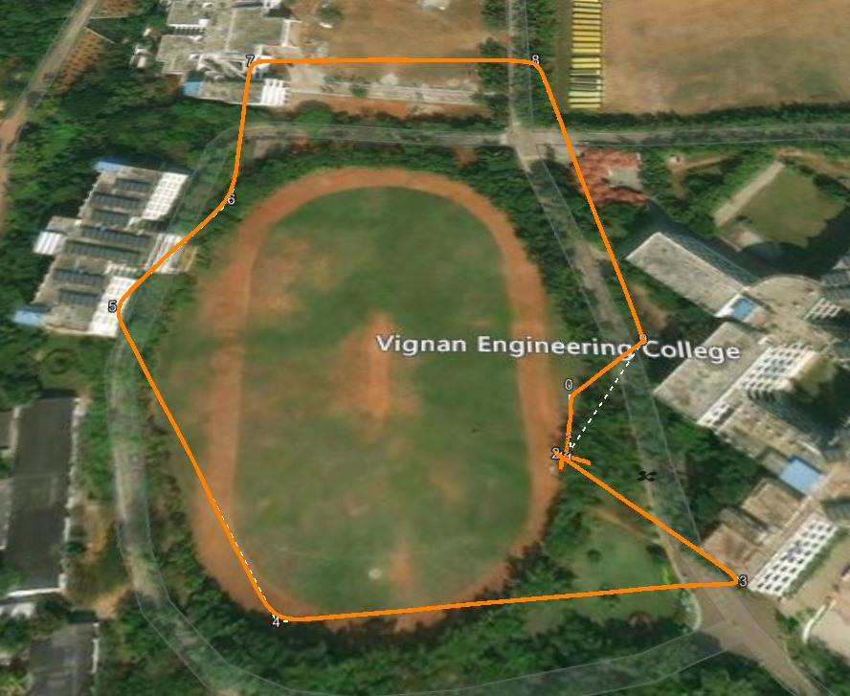

Cricket ground way points

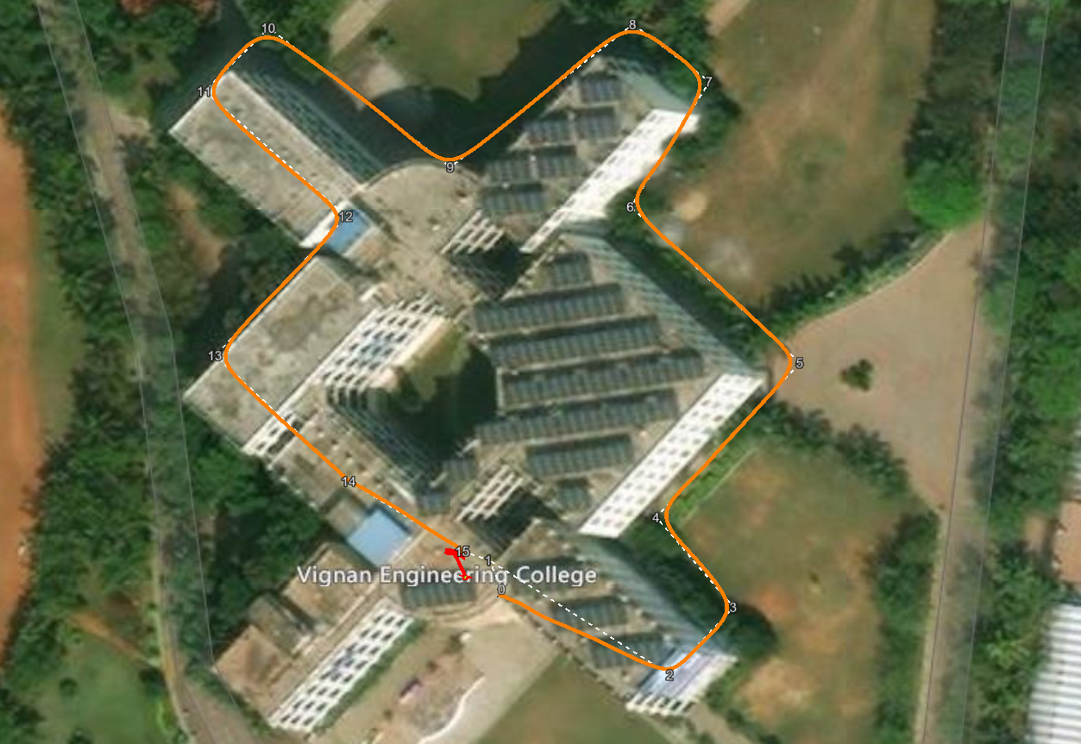

Main block way points

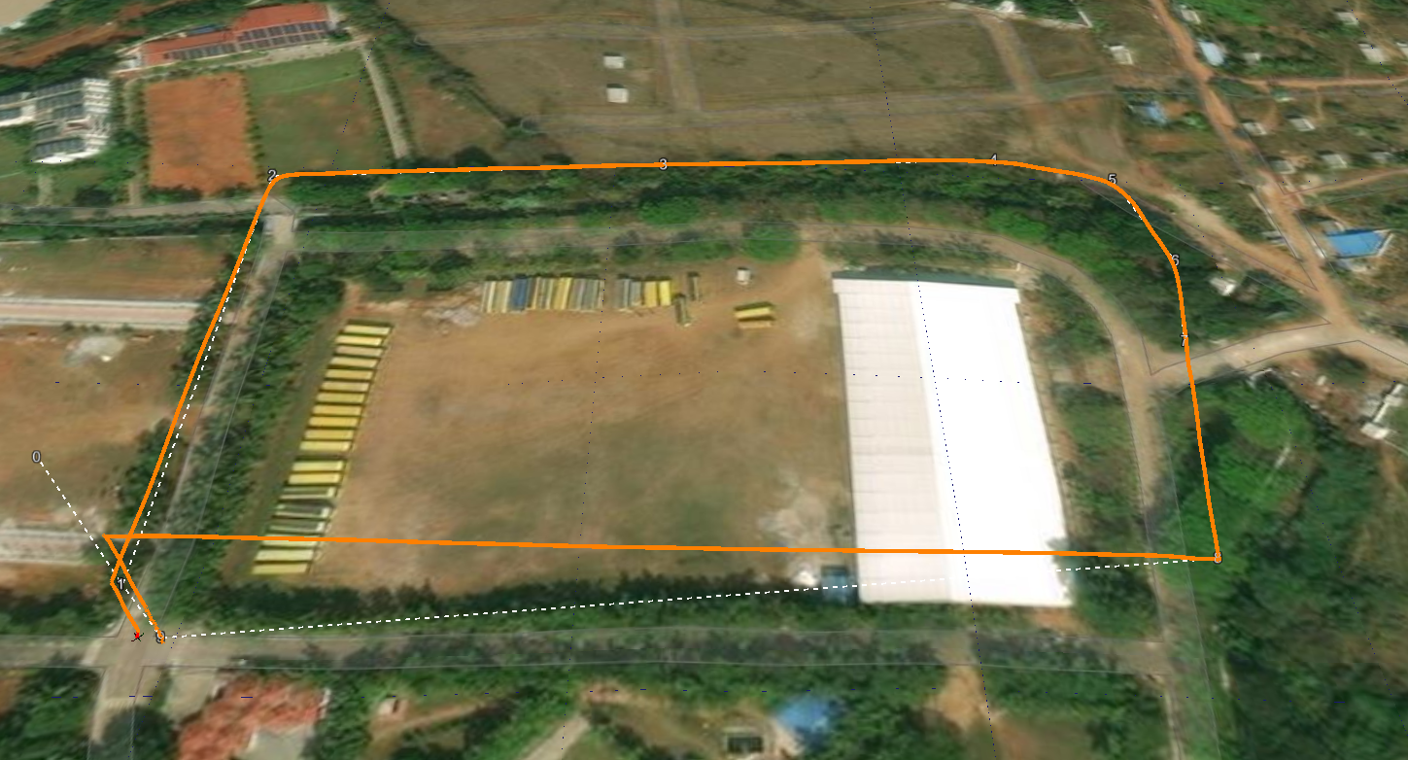

Football ground path

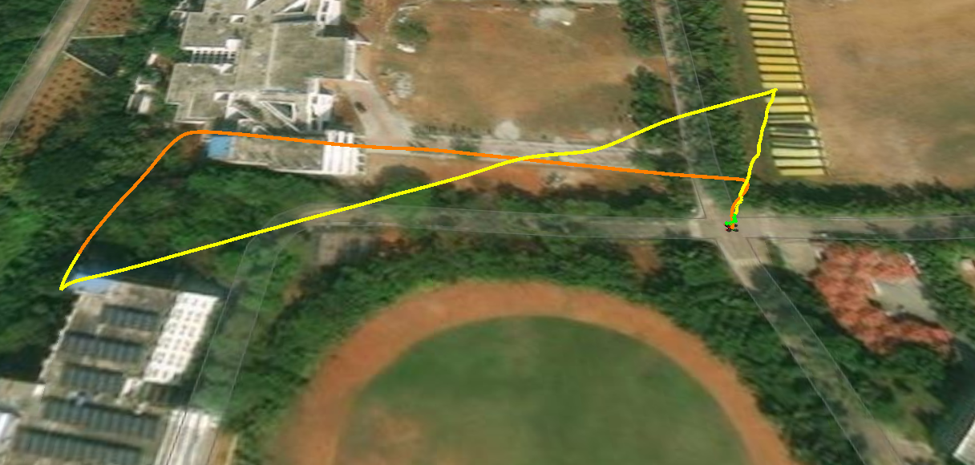

Autopilot RTL testing.

**Consideration one of the above paths for the analysis purpose.**

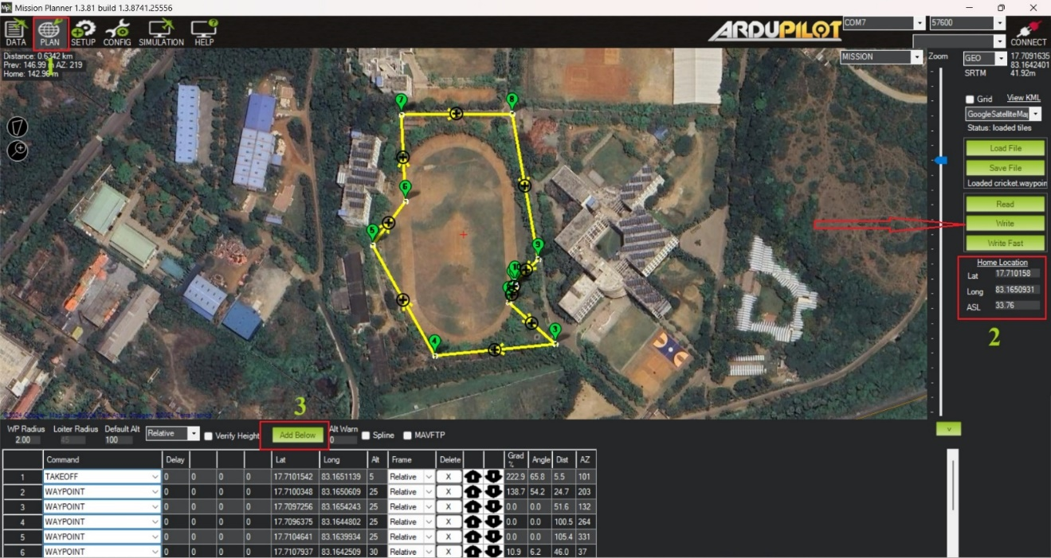

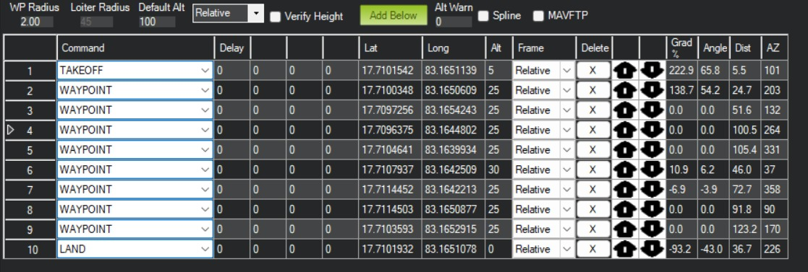

Waypoints

STEP 1: To set up the mission, Select the PLAN in the home menu. An interface with a map will open.

STEP 2: The second step is to observe the home point location. The drone's live GPS coordinates should be the home point. If the point does not match, drag and drop the home point to the drone location.

STEP 3: after the selection of the home point, select the add below option to insert the waypoints as per the user's need. The first and last waypoint should be the take-off and land option. The between waypoints option can be modified according to the user, for example (RTL, position hold, loiter, and delay).

**Upload Mission:** To upload the mission waypoints to your autopilot system, click the "Write WPs" button in Mission Planner. It is indicated by the red arrow

**Activate Autonomous Flight**: Turn on autonomous flying by arming the autopilot, configuring your transmitter to the proper flight mode (for example, "Auto"), and initiating the mission using Mission Planner.

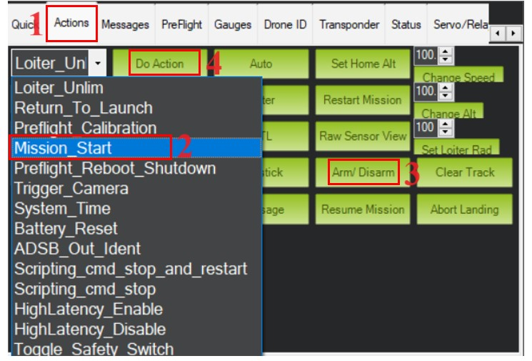

Mission initializing

**Initializing mission:**

STEP 1: Move to the DATA window and select the action tab.

STEP 2: CLEAR the LOITER and select the Mission_Start,

STEP 3: Turn on the drone by toggling the ARM option. This will force-arm the drone without the use of a transmitter

STEP 4: Initialize the path flight by clicking the DO ACTION option button.

After initialising the mission, quadcopter will fly by in the path by following the waypoints as mentioned in the mission planner software.

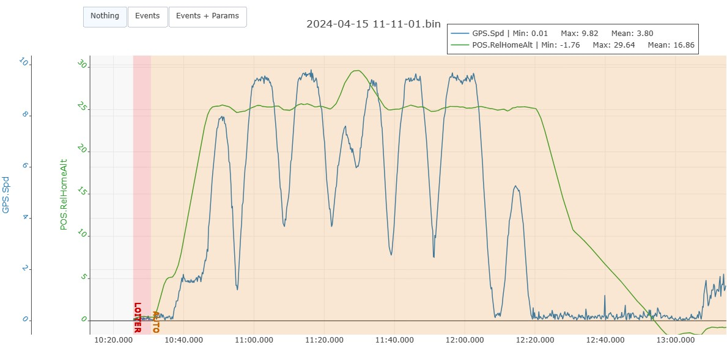

From the above graph the altitude and speed can be observed as given in quadcopter waypoints.

The maiximum speed reached by the UAV is 9.82 m/s the deviation in the altitude is 11.002

**Uploading Of Flight Paths**

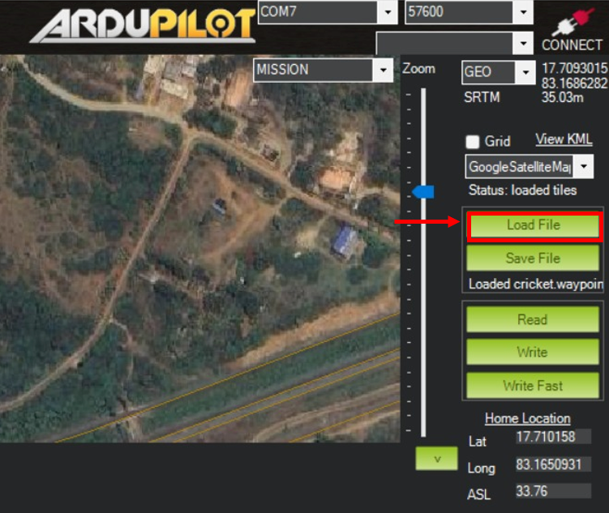

For selecting multiple paths, first we have to predefine various waypoints and home location and save it in a folder. Now click on Load file,

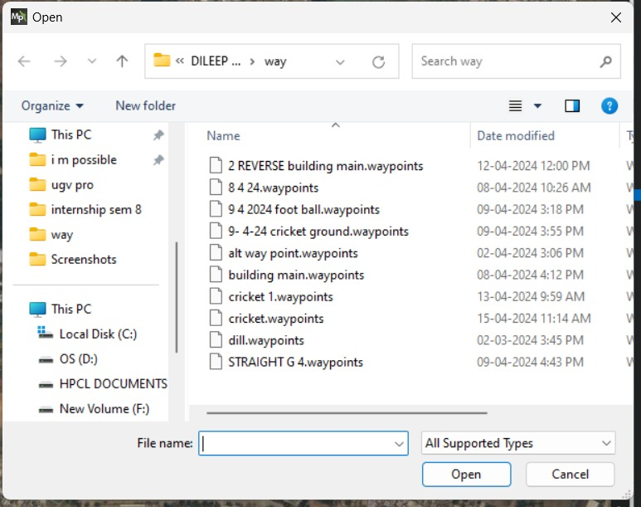

Flight path files window

## Video Transmission and Receiving

Upon activation, the video transmitter looks for a video signal and chooses the necessary radio frequency and channel. Since the camera needs between 5 and 12 volts, power for it comes from the Pixhawk flight controller's aux.1 out (7V). The 5.8GHz Sky droid recover is attached to the device for watching in order to receive the video feed from the transmitter.

The FPV application immediately detects the receiver when it is connected to the mobile device via a USB type-c cable. When it detects a stronger signal, it holds the streaming frequency.

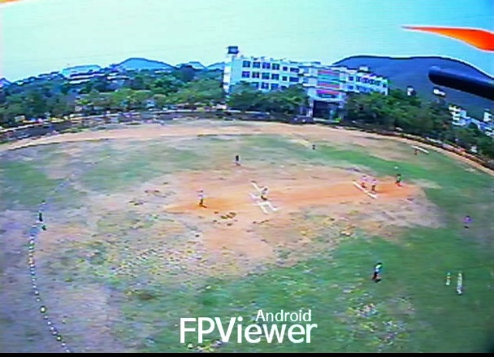 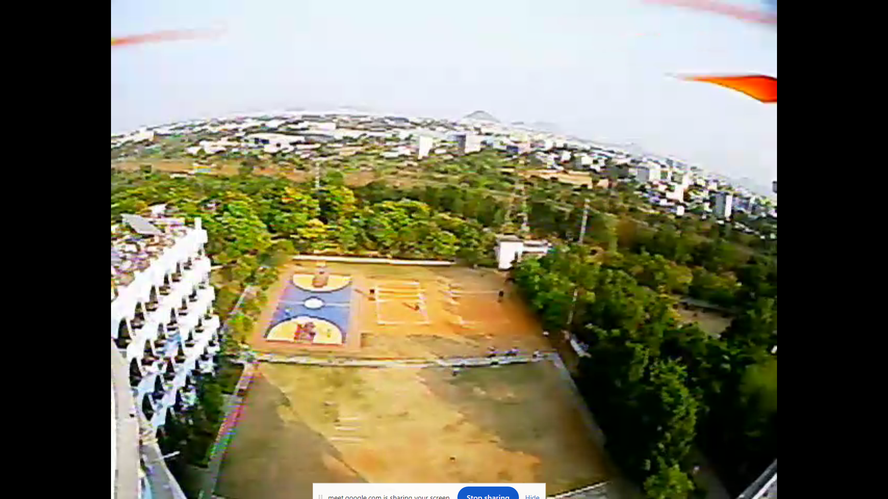

**FP Viewer in android and Video stream in PC**

# Results The deployment of autonomous surveillance drones programmed to traverse various paths has good results, profoundly transforming surveillance capabilities. The speed reached by the UAV is 9.82 m/s. From the above test paths the observation is the test path deviations are way lesser than the deviation in the manual operations and the average time taken for the paths is 2min, the stabilization of the Pixhawk flight controller is more in autopilot than the manual mode. The RTL interruption test of the autopilot mode is changing the path spline which makes the UAV to return to the launch paths as the waypoint is overwritten with the RTL mode.

# Conclusion

Drones have greatly improved surveillance coverage by following different routes, which allows for a more thorough scanning of larger areas in less time than with manual methods. This method maximizes the effectiveness of surveillance by allowing operators to choose the best course of action based on particular goals and environmental factors, giving them more flexibility in mission planning. These drones' real-time video feeds and MS5611 barometer, the MPU6000 gyroscope sensors data give operators a better situational awareness, enabling them to react quickly to possible threats or incidents. Drones with adaptive path-following capabilities can also dynamically modify their trajectories to ensure optimal performance in changing environments and lessen operator workload. Autonomous surveillance drone systems are more useful for a variety of applications, such as border security, infrastructure monitoring, and emergency response, due to their scalability, affordability and efficient successful monitoring in a range of operational scenarios.